Minutes of CEPC Accelerator Physics Meeting
2016.11.04

Place: Room C407, Main Building, IHEP
Convener: Jie Gao
Attendee: Cai Meng, Dou Wang, Yiwei Wang, Sha Bai, Feng Su, Tianjian Bian, Zhenchao Liu, Hongjuan Zheng, Na Wang, Yuansheng Sun, Jin Wu, Song Jin
Recorder：Dou Wang
Summary of minutes：
  - Firstly, Dou reported about CEPC DA optimization with Yiwei’s lattice (CEPC_ARC_PDR_IR_96fam_damp). She has used Mode which is developed by Yuan Zhang. After optimization, the off-momentum DA (2%) is two times larger than the initial one.
  - Hongjuan give a summary of her study about HOM coupler design and collective instability. The key point is as follows:
    - The preliminary design of HOM coupler is given.
    - The bunch lengthening analysis results show that the bunch lengthening is a problem for CEPC, especially for Z design.
  - Yiwei reported his progress on PDR DA study. He has inserted the new designed crab section into IR and the study of DA optimization is ongoing.
  - Sha Bai reported about PDR multipole error effect on DA. BEPCII multipole error are used on CEPC. With BEPCII multipole error, off-momentum DA larger than ±0.5% is zero.

The next meeting will be on November 11, 2016.

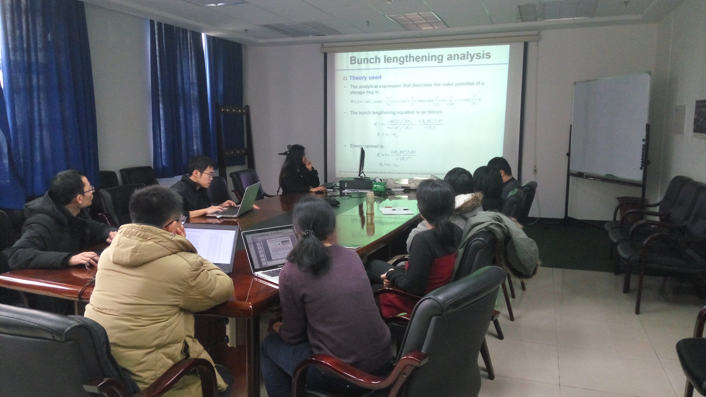

Recorder：Dou Wang
Checkup：Jie Gao
2016-11-04

