Minutes of CEPC Accelerator Physics Meeting
2016.11.11

Place: Room C407, Main Building, IHEP
Convener: Jie Gao
Attendee: Jie Gao, Qin Qing, Chenghui Yu, Meng Cai, Huiping Geng, Dou Wang, Sha Bai, Feng Su, Tianjian Bian, Na Wang, Hongjuan Zheng, Yuansheng Sun, Jin Wu, Song Jin, Dianjun Gong
Recorder：Dou Wang
Summary of minutes：
  - Firstly, Prof. Qin introduced the status of IAC meeting. He announced the change for CEPC circumference and the participation of Prof. Yu.
  - Prof. Gao reviewed the comment/suggestions from IAC-report. Also he suggested change the time of CEPC regular meeting to 8:30am.
  - Dou introduced the primary Higgs parameters for 100km CEPC.
Prof. Gao suggested increase the IP betay from 1mm to 2mm in order to ease the FFS optics design.
  - Sawtooth effect discussion.
Prof. Yu suggested adjust the magnet’s strength as the beam energy manually to simulate the sawtooth effect.
  - Hongjuan introduced the principle of RF system design for CEPC.

The next meeting will be on November 18, 2016.

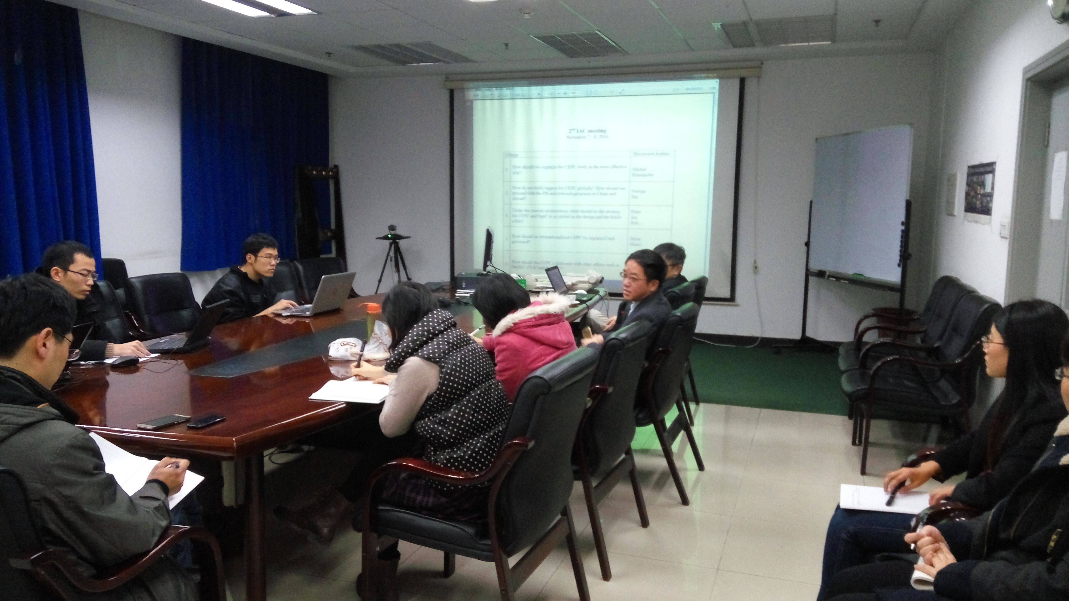

Recorder：Dou Wang
Checkup：Jie Gao
2016-11-11

