Minutes of CEPC Accelerator Physics Meeting
2016.11.25

Place: Room C407, Main Building, IHEP
Convener: Jie Gao
Attendee: Chou Weiren, Chenghui Yu, Huiping Geng, Yoshihiro Funakoshi (KEK), Dou Wang, Sha Bai, Feng Su, Tianjian Bian, Na Wang, Yuansheng Sun, Jin Wu, Song Jin
Recorder：Dou Wang
Summary of minutes：
  - Firstly, Dou reported about the new 100km CEPC Parameters. She showed both double ring parameters (including Higgs, W and Z) and single ring parameters. Also she gave the new lattice design of arc for 100 km CEPC. All the parameters consistant with parameter table.
Prof. Yu suggested increase the emittance of Z parameter in order to increase the luminosity.
  - Huiping reported her study of CEPC single ring sawtooth effect. She has added the energy deviation for quadrupoles and sextupoles in FFS manually to see the sawtooth effect on single ring. She found that sawtooth effect in FFS makes the lattice unstable.
  - Sha Bai reported her progress on sawtooth effect of CEPC PDR. She has tried two methods to see the sawtooth effect: Scale magnets manually, use the newest SAD version. She found that off-momentum DA reduced a lot with sawtooth effect.

The next meeting will be on December 2, 2016.

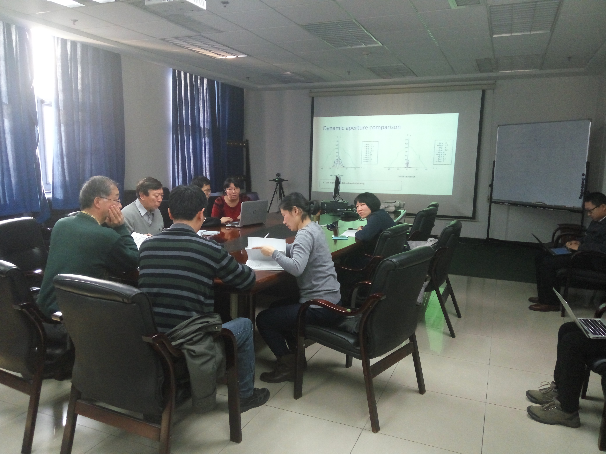

Recorder：Dou Wang
Checkup：Jie Gao
2016-11-25

