Minutes of CEPC Accelerator Physics Meeting
2016.12.09

Place: Room C407, Main Building, IHEP
Convener: Jie Gao
Host: Qing Qin
Attendee: Qing Qin, Chenghui Yu, Yiwei Wang, Cai Meng, Dou Wang, Sha Bai, Feng Su, Na Wang, Jin Wu, Song Jin
Recorder：Dou Wang
Summary of minutes：
  - Sha Bai reported her progress on sawtooth effect of CEPC PDR. Key points are as follow:
    - With sawtooth effect, tune change at 3 digits after the decimal point.
    - Both On-momentum and Off-momentum DA reduced a lot with sawtooth effect. Off-momentum DA beyond 0.5% reduced to zero.
    - Resonance coefficients at interaction point with sawtooth change a lot compared with no sawtooth.
    - Reduce Synchrotron radiation to 1/20, DA still can not recovered.

The next meeting will be on December 16, 2016.

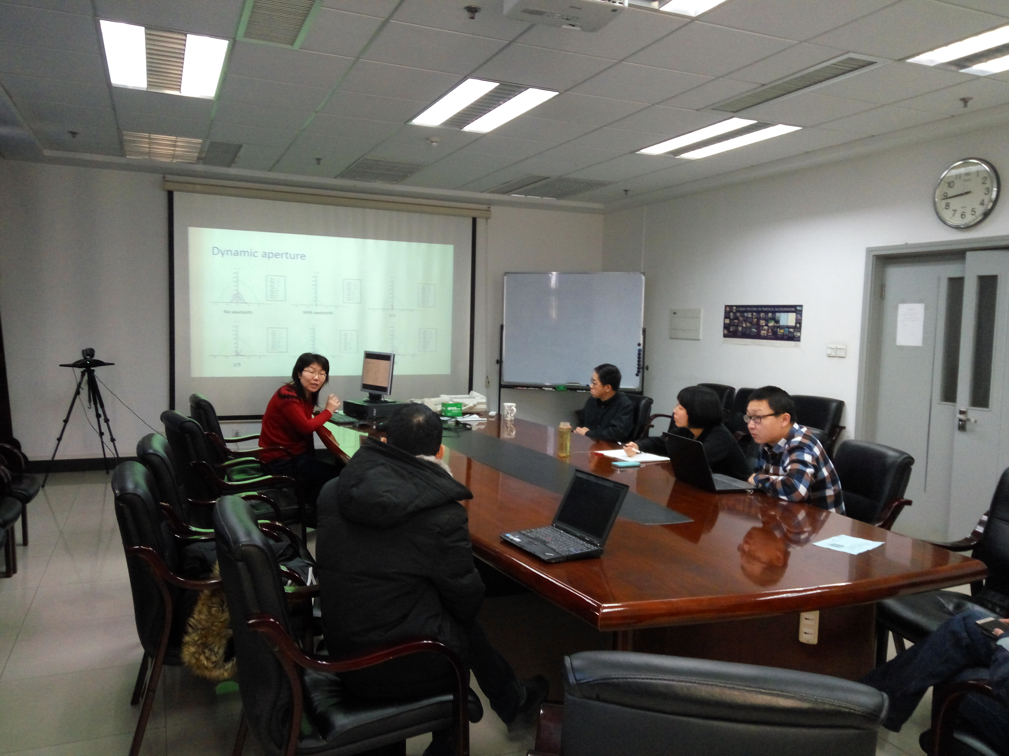

Recorder：Dou Wang
Checkup：Jie Gao
2016-12-09

