Minutes of CEPC Accelerator Physics Meeting
2016.12.16

Place: Room C407, Main Building, IHEP
Convener: Jie Gao
Attendee: Jie Gao, Chenghui Yu, Yuan Zhang, Huiping Geng, Yiwei Wang, Cai Meng, Dou Wang, Sha Bai, Feng Su, Na Wang, Yuansheng Sun, Jin Wu, Song Jin, Zhenchao Liu
Recorder：Dou Wang
Summary of minutes：
  - Firstly, Dou reported about the new 100km CEPC Parameters. She showed both double ring parameters (including Higgs, W and Z) and single ring parameters. Two cases for Higgs with 1mm betay and 2mm betay were explained. Also she gave the new lattice design of FFS for 100 km CEPC. The critical energy of dipole in FFS was reduced under 100kev by lengthening the FFS.
Prof. Gao suggested to check the DA of bare lattice without IR.
  - Feng Su introduced his progress about CEPC double ring lattice design.
  - Yiwei also reported the study of 100 km double ring. Lattice design and survey for ARC and RF section has been finished.
  - Huiping reported her study of CEPC single ring sawtooth effect. She has added the energy deviation for quadrupoles and sextupoles in FFS manually to see the sawtooth effect on single ring. She found that sawtooth effect mainly comes from FFS.
  - Sha Bai reported her progress on sawtooth effect of CEPC PDR and APDR. With sawtooth effect, the horizontal motion was unstable. The horizontal tune became zero and DA reduced to zero with sawtooth effect.
  - Yuan Zhang introduced the newest measurement study of beam loading on BEPCII.

The next meeting will be on December 23, 2016.

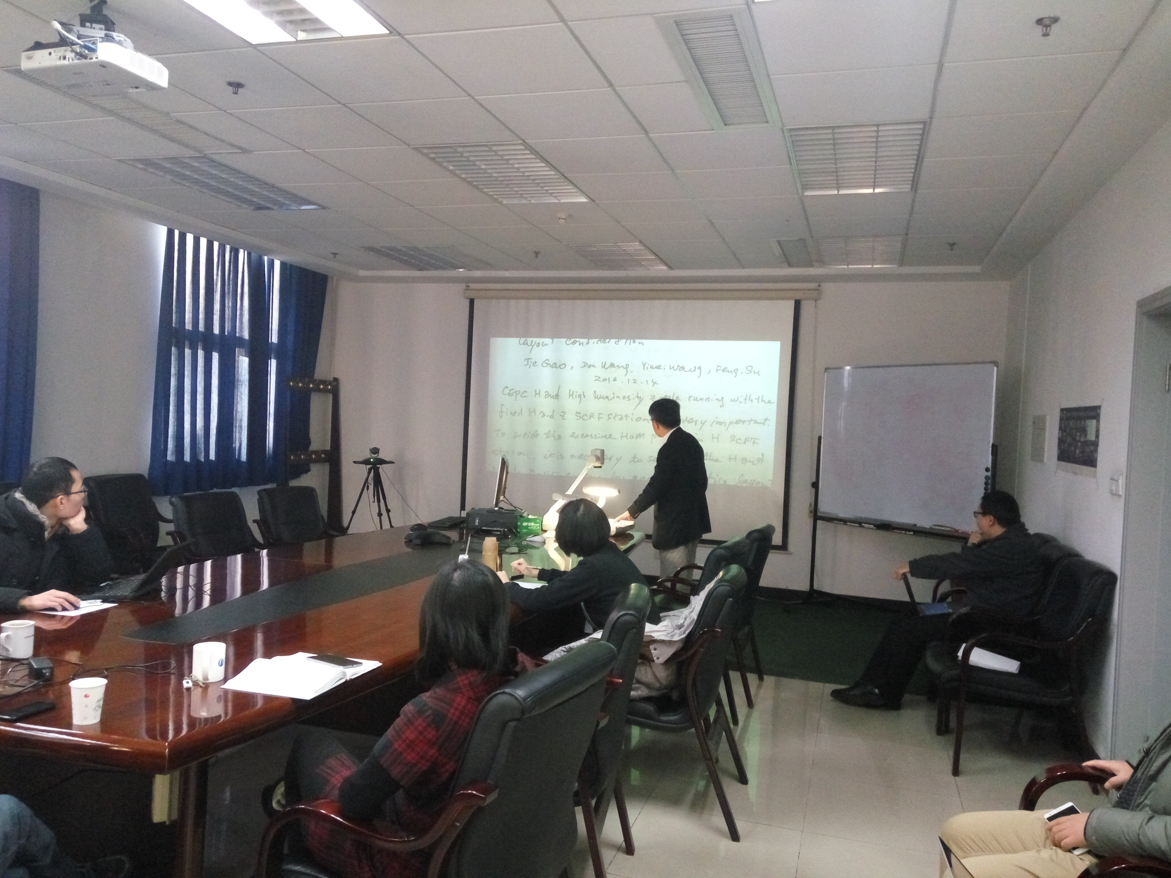

Recorder：Dou Wang
Checkup：Jie Gao
2016-12-16

