**RF and Beam-Cavity Interaction**

**Home Work Solutions**

1. **Calculate R/Q value of TM010 and TM110 mode of a 1.3 GHz pillbox cavity. The cavity length is half of the RF wavelength.**

**Solution:**

1. R/Q of TM010 mode













*ν*01 is *J*0(*x*)’s first root







1. R/Q of TM110 mode













where *ν*11 is the first root of *J*1(*x*)



Near axis: ，







1. **Calculate field flatness with cell frequency error of a 650 MHz 2-cell cavity. Pi-mode frequency of one cell is 649.8 MHz, and the other is 649.3 MHz. (Use RF circuit perturbation method). Cell-to-cell coupling factor *k* = 1.58 %.**

**Solution:**

The cell frequencies: $f_{1}=649.8 \text{MHz,} { f}_{2}=649.3 \text{MHz}$

Cell number: N=2

Cell-to-cell coupling factor *k* = 1.58 %.

Cavity $π$ mode frequency: $f_{π}=\frac{ f_{1}+ f_{2}}{2}=649.55 \text{MHz}$

$j_{th}$ cell voltage for mode m: $v_{(m,j)}=B_{m}sin⁡[mπ(\frac{2j-1}{2N})]$

where, the normalizing coefficient: $B_{m}=\sqrt{\frac{2-δ\left(m,N\right)}{N}}$

Frequency for mode m: $Ω_{m}=1+2k[1-cos⁡(\frac{mπ}{N})]$

Voltage matrix for 2-cell cavity

$v=\left(\begin{matrix}0.7071 & 0.7071 \\ 0.7071 & -0.7071\end{matrix}\right)$ (1)

Frequency for 2-cell cavity:

$Ω=$ (1.0316, 1.0632) (2)

For an out-of-tune cavity, the cell error for the $j_{th}$ cell is:

$$e_{j}=2*(\frac{f_{j}-f_{π}}{f_{π}})$$

For 2-cell cavity, the cell error vector is:

e = (0.00077, - 0.00077) (3)

Including the cell errors, the cell voltages for the $j_{th}$ cell can be rewritten as:

${v_{(m,j)}}^{'}=v_{(m,j)}+\sum_{n≠m}{\frac{1}{Ω_{m}-Ω_{n}}\sum_{j}{v_{(m,j)}e_{j}v_{\left(n,j\right)}*v_{\left(n,j\right)}}}$ (4)

Substitute Eq.(1), Eq.(2) and Eq.(3) into Eq.(4), the cell voltages for 2-cell cavity are:

$$v^{'}=(0.724,-0.69)$$

The field flatness is F = 0.69 / 0.724*100 % = 95.2 %

1. **Suppose a pickup is on the same side of the cavity beam tube as the input coupler. The accelerating mode signal directly coupled from the input coupler to the pickup rather than from the field of cavity is called “cross talk”. Prove that the relative cross talk signal is much smaller (~ 1E-4) at 2 K than at room temperature. Explain the shape of the cross talk signal.**

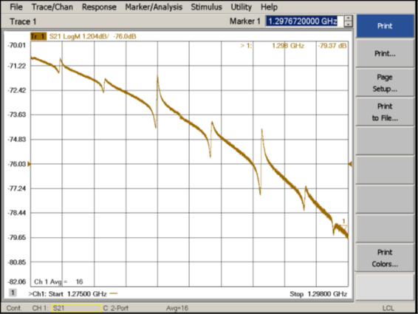

**Solution:**

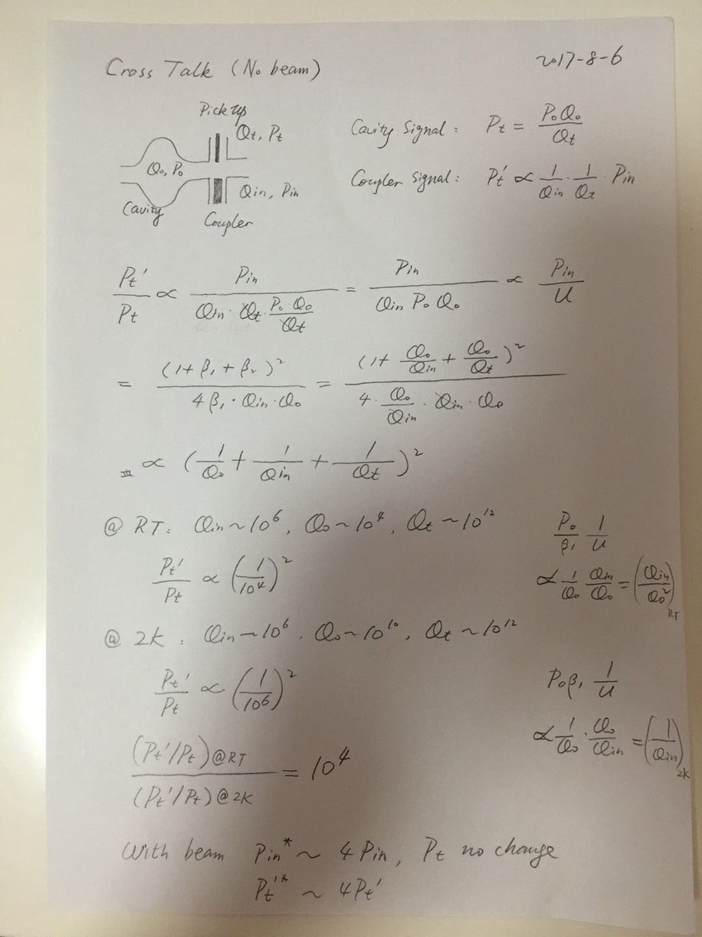

1. **Calculate injection time (in terms of filling time τ) for a pulsed superconducting linac (on crest beam acceleration) to have same bunch energy in the bunch train.**





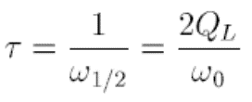

**Solution:**

In the steady state for a superconducting cavity with beam, the amplitude of *I*g is twice of *I*b. Same bunch energy in the bunch train means the constant *V*c from the time *t*inj to the steady state. Take time derivation of the two sides of the equation and we get *t*inj = *τ* ln2.

1. **Calculate the growth rate of Robinson instability with CEPC Z-pole parameters. Suppose the cavity frequency is tuned 400 Hz above the RF frequency. Compare that with the radiation damping rate.**

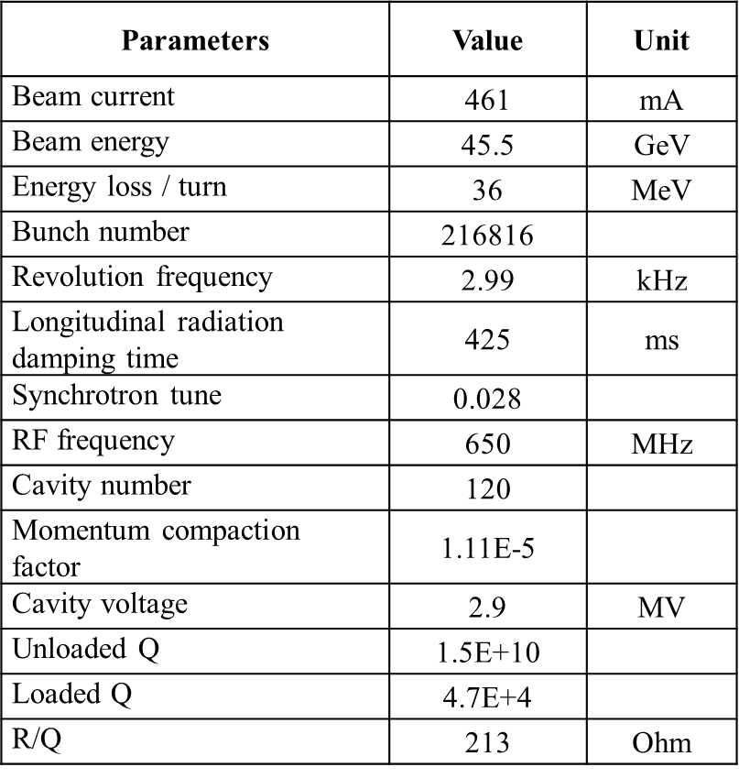

**Solution:**

Cavity fundamental mode resonance frequency: $f_{res}=f_{rf}+∆f$

Longitudinal coupling-impedance of cavity: $Z^{||}(f)=\frac{1}{β}\frac{{R_{sh}}/2}{\left.1+iQ_{L}(\frac{f}{f_{res}}-\frac{f_{res}}{f}\right)}$

Growth rate of Robinson instability is given:



$f^{+}=f_{rf}+f_{s}$, $f^{-}=f_{rf}-f_{s}$

The Robinson instability growth rate as a function of cavity detuned frequency is plotted:

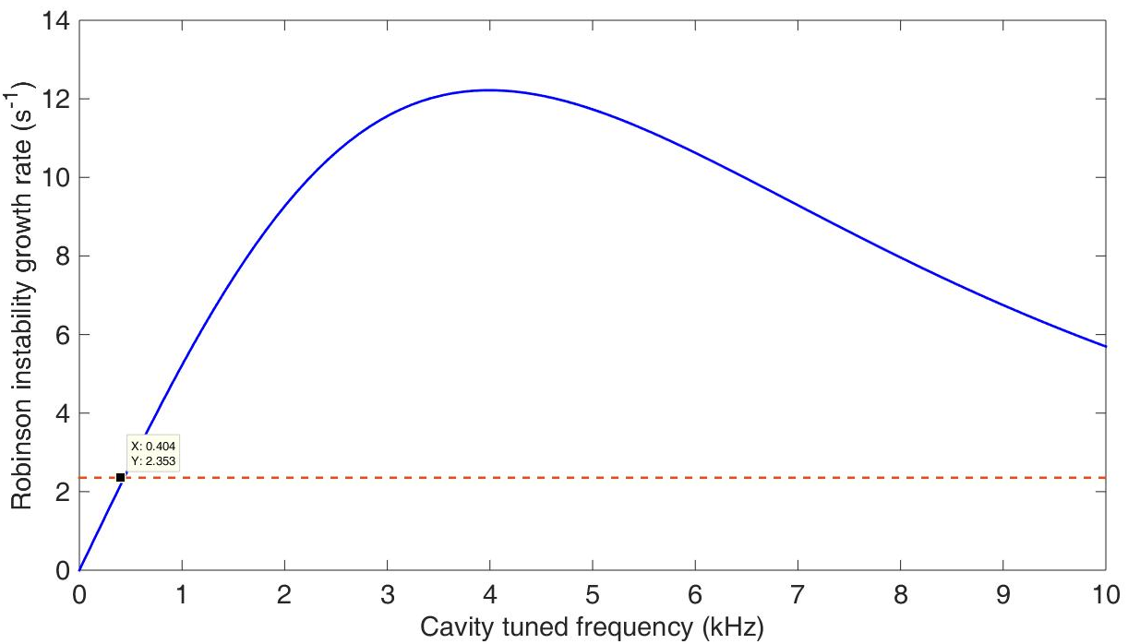

The growth rate for 400 Hz positive detuning is 2.35 s-1.